v.2.72, 14-01-2007

CREATING DIGITAL LIBRARIES BASED ON CDS/ISIS DATABASES

by Pablo Morete and John Rose

This guide is intended to help users of UNESCO's CDS/ISIS software to convert their databases to digital libraries under the Greenstone Digital Library program.

It is strongly recommended that users wishing to convert CDS/ISIS databases to Greenstone digital libraries utilize the most recent stable Greenstone (version 2.72 at the time of writing which can be downloaded from the website at http://www.greenstone.org (users without an appropriate Internet connection to download the latest version may choose to use version 2.70 provided on the 2006 UNESCO Greenstone CD-ROM). DO NOT use version 2.71. Some conversion functionality can be obtained on earlier versions of Greenstone, but the conversion is likely to be more difficult and the results less satisfactory.

This version of the guide is an interim update to take account of changes between Greenstone versions 2.70 and 2.72. Unless specified to the contrary, the screen-shots are taken from version 2.70, but differences concerning version 2.72 are noted.

Like all Greenstone applications, libraries converted from CDS/ISIS can be disseminated on multiple Web platforms (Windows, Unix, Linux, Mac OS X) or on CD-ROM. Two types of conversion are possible:

- "As is" conversion of a CDS/ISIS database to a Greenstone digital library. Since CDS/ISIS records are limited to 32,000 characters (in version 1.5), CDS/ISIS databases generally do not contain the full text of documents; this first type of conversion is thus normally used to provide easier Web or CD-ROM access to a bibliographic or referral database (through indexing or browsing on any of the CDS/ISIS fields). If any of the CDS/ISIS fields contain hyperlinks to external resources, they will be active in the resultant Greenstone library. The Greenstone library cannot be enlarged or edited in Greenstone; it will typically be generated periodically from the master CDS/ISIS database.

- Creation of a Greenstone digital library of full-text documents from a CDS/ISIS bibliographic database and the files containing the full-text documents associated with the database records. This means that the original document can be imported into Greenstone (from a storage device available to your computer or from the Internet); and that the text of the document and/or the CDS/ISIS metadata can be accessed through indexing or browsing on any of the CDS/ISIS fields. The resulting digital library can then be updated/maintained as an autonomous application, or if preferred can be periodically regenerated from the master CDS/ISIS database with associated documents. This method can also be implemented with dummy documents to enable a library based only on CDS/ISIS metadata to be enlarged or edited in Greenstone.

The second type of conversion is of particular interest for CDS/ISIS users, since it enables one to provide full digital library services (indexed access to original documents) while retaining all of the power and flexibility of CDS/ISIS in the handling of the corresponding metadata.

Both types of CDS/ISIS to Greenstone conversion will be documented in the first two parts of this guide:
1 - IMPORTING A CDS/ISIS DATABASE INTO GREENSTONE (page 3)
2- ASSIGNING CDS/ISIS METADATA TO ELECTRONIC DOCUMENTS (page 7)
while the third part will briefly address the issue of configuring the user interface once the database is converted:
3- CONFIGURING THE USER INTERFACE (page 14)
and the final part will treat problems which may arise with very large CDS/ISIS databases:
4- CONVERTING VERY LARGE CDS/ISIS DATABASES (page 26).

In order to follow these instructions, the user should first become familiar with the basic use of the Greenstone Librarian Interface (GLI) in creating digital libraries.

The instructions and screen-shots in this guide are based on the default "Librarian" mode of operation of GLI. If another mode is used the appearance of the screens will be different, but the basic functionality will be the same.

- IMPORTING A CDS/ISIS DATABASE INTO GREENSTONE

This procedure converts a CDS/ISIS database "as is" into a Greenstone digital library. It requires the ISISPlug plugin (loaded by default in a new Greenstone library or one based on the CDS/ISIS example collection).

The following steps should be followed:
  - Load the Greenstone Librarian Interface (GLI) create a new collection by clicking on the File/New... main menu item, providing a short collection name (for convenience it could be the name of CDS/ISIS database) and a description. Keep the default setting for "Base this collection on:" as -- New Collection --, then click on OK (see Figure 1). The GLI interface with tabs to select from six panels (five in version 2.70) will appear. In version 2.72, Dublin Core will have been assigned by default as your metadata set. If you want to use only the existing CDS/ISIS fields as your metadata, then it is convenient to remove the Dublin Core metadata set at this time (rather than later being asked whether or not to use these metadata elements). Go to the Enrich panel, click on the Manage Metadata Sets ... button, and remove the Dublin Core metadata set.

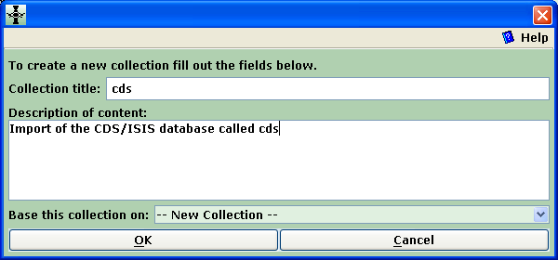
Figure 1: Creating a new collection

  - The GLI Gather panel will appear. Locate the MST, XRF, and FDT files from your CDS/ISIS database in the directory tree of Workspace pane (normally they will be in the "C:\WINISIS\DATA\" directory of the Local Filespace) and drag them one by one into the Collection pane. When you copy MST file into the Collection pane Greenstone could propose to load ISISPlug (it will be loaded by default in version 2.70 or above); in that case accept the proposal. Note that if all three files do not show in the Collection pane, an error will be generated at the later "build" or "explode" steps; in that case just come back to the Gather panel, drag in the missing files and continue.

You will then have the screen shown in Figure 2.

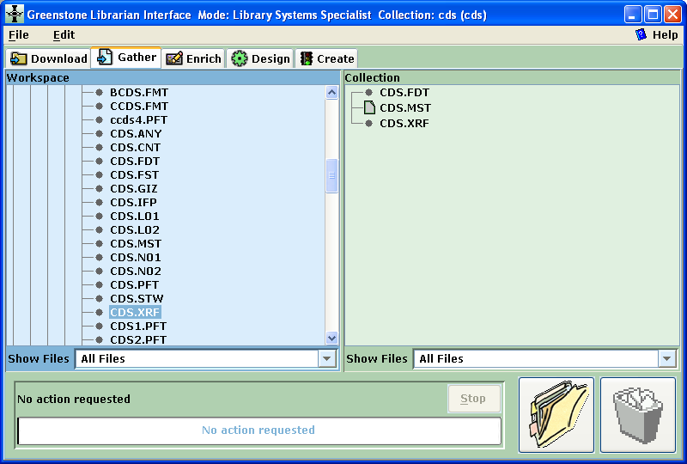
Figure 2: Collection files ready to process

  - If you are using non-ASCII characters in your database, go to the Design panel and click on Document Plugins. Then click on ISISPlug and on Configure Plugin (see Figure 3). Check input_encoding and select the appropriate DOS codepage (for Latin alphabets using accented letters, it is "dos_850-DOS codepage 850 (Latin 1)") and click OK. This will set ISISPlug to correctly recognize the character set of your database (see Figure 4).

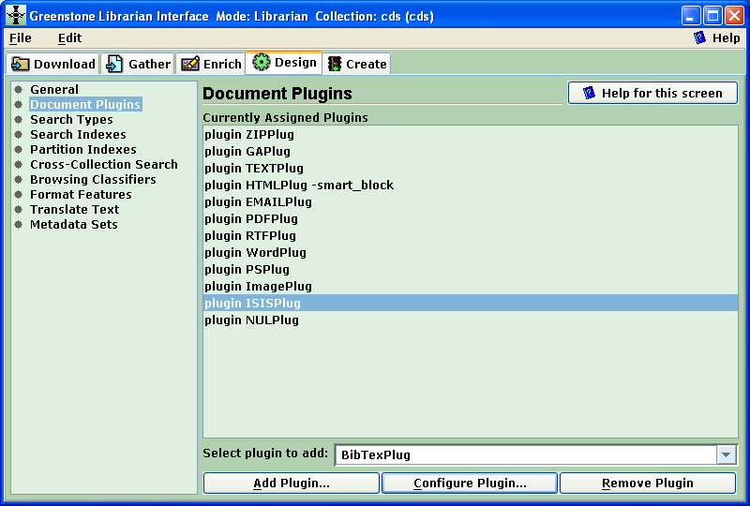
Figure 3: Select the ISISPlug under Document Plugins in the Design panel

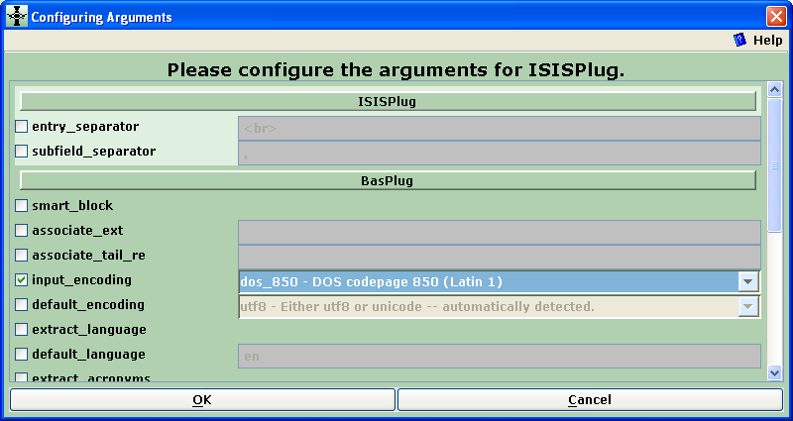
Figure 4: Select the appropriate character encoding scheme

If either i) you want to incorporate and index electronic document files into your Greenstone library or ii) you want to edit metadata in Greenstone (not enabled for "as is" conversion which is intended only for Web display or CD-ROM distribution of the CDS/ISIS database), then go to Part 2 on "Assigning CDS/ISIS Metadata to Electronic Documents". If on the other hand your CDS/ISIS database is a self-contained resource database pointing to paper documents, or to electronic documents which you do not need to physically integrate into the digital library, continue with the steps just below.

  - Go to the Create panel of GLI and click on Build Collection (see Figure 5).,

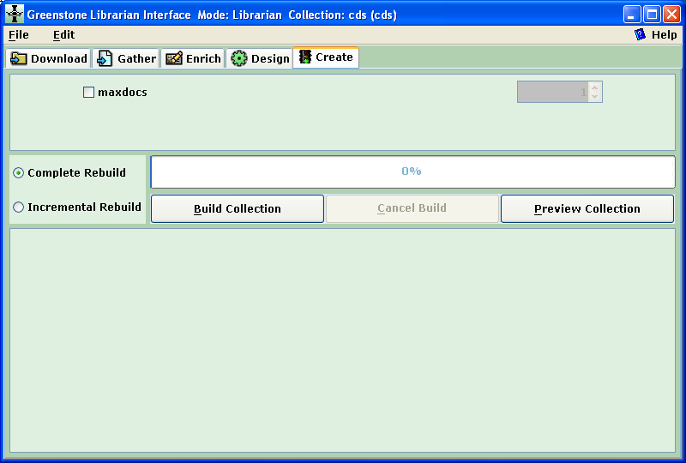
Figure 5: The Build Collection button in the Create panel

  - Normally after several seconds or minutes (depending on the size of your database, it could be even longer), a box may appear informing you that the collection has been built (see Figure 6), and you may then preview it by clicking on the "Preview Collection" button (This step can be eliminated in the future by checking the "Do not show this message again" box and clicking on OK).

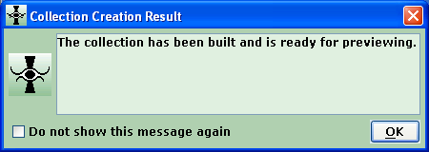
Figure 6: Box announcing that the collection has been built

  - By default the new collection will be in simple search mode (single search index) with two browsing classifiers ("titles" and "filenames") and a standard record display format listing the CDS/ISIS field names and field content in order of CDS/ISIS tag number. To provide an appropriate user interface to the collection, you will now need to configure your search types, search indexes and browsing classifiers in the Design panel. This is a task common to all Greenstone collections, for which some specific guidance and general references are given in Part 3.

It is possible to convert more than one CDS/ISIS databases into a single Greenstone collection, combining the metadata records of each. To do this, simply drag the files of all of the source databases (which can have different metadata structures) into the Collection pane before building (or rebuilding).

BASING THE COLLECTION ON THE GREENSTONE CDS/ISIS EXAMPLE:

The CDS/ISIS example collection of Greenstone (called isis-e) was developed for version 2.50, before the explode functionality existed and before a formatted version of the CDS/ISIS record was included as the record text in an "as is" conversion (previously it was a raw record, see Part 3, Section E under DocumentText). This collection is now of interest mainly for didactic purposes, unless you are planning only an "as is" conversion and i) the metadata structure of your CDS/ISIS database is similar to that of the example collection (based on the sample database provided with CDS/ISIS which uses the bibliographic format of UNESCO's library) and ii) you wish to display your data as a user defined record display format with an option to additionally show or hide the full CDS/ISIS record.

To apply this method, specify when you create the Greenstone collection that it is to be based on the "CDS/ISIS example (isis-e)" by selecting this in the drop-down list for the parameter: "Base this collection on:" in the initial screen for creating the collection (see Figure 1). If your fields correspond exactly to those in the example, your library will work just as the example after you complete steps B-E above (provided that, for versions of Greenstone prior to 2.70, you replace "isis-e" in the two "&c=isis-e" specifications of the 'format DocumentText' statement (Design panel, Format Features) by the short name of your Greenstone collection (see Figure 7, and also Part 3, Section E concerning editing of formats in the Format Features view).

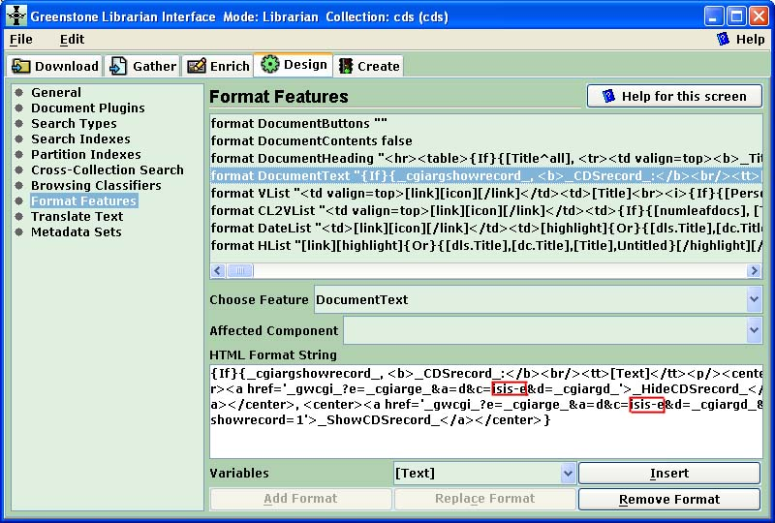
Figure 7: Format parameter to change (shown within the red box in HTML Format String)

If your CDS/ISIS fields differ from the example (based on UNESCO's bibliographic database), the full record display will be correct, but the record initially displayed will only show those fields whose names are identical to those of the example (and nothing if none are the same). In this case you should modify the initial user defined record display format by editing the Document_Heading format in the Design panel, Format Features, as explained in the Bibliography collection (cltbib-e) (see also the general guidance on formatting in in Part 3, Section E, but note that, the Document Heading format will display starting from its end and has to be scrolled to backwards to be edited). Note also that no records may appear for display if the search indexes and browsing classifiers have not been customized (see Part 3); in that case you can fetch the records by searching on "raw record" in the search form.

Remember that if you are going on to assign CDS/ISIS metadata to electronic documents (second type of database conversion), there is no need to improve the display interface of the simple "as is" Greenstone collection based only on metadata, or to base your collection on the Greenstone example which is only for metadata display.

- ASSIGNING CDS/ISIS METADATA TO ELECTRONIC DOCUMENTS

The "Explode Metadata Set" option" provides a way of reorganizing a Greenstone collection consisting of metadata only (e.g. "as is" conversion of a CDS/ISIS database) so that each record appears as an individual document with the associated metadata assigned to it. The explode option is a functionality of the ISISPlug plugin, which must be loaded as in the case of an "as is" conversion.

Exploding metadata is an irreversible process, so that if you have built an "as is" CDS/ISIS library in Greenstone, and want to keep the data and/or the configuration (e.g. search types, search indexes, browsing classifiers, and display formats), save it before going on with this step (this is most easily done by duplicating the entire collection with another name in the Greenstone\collect\ directory).

In the Gather panel, you will notice that the MST file has a different coloured icon than the other files. This green icon indicates that the file it is a metadata database that can be exploded. Right-click on the icon and choose Explode metadata database by right clicking on this line in the menu (see Figure 8).

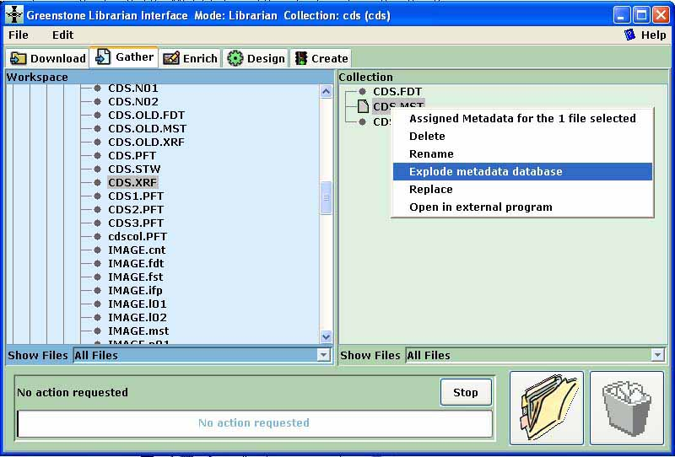
Figure 8: Menu presented after right click on the MST file

There are now two ways to integrate the electronic documents into the collection: A) automatically importing them through a hyperlink existing in the CDS/ISIS database or B) creating dummy files which are later replaced by the corresponding documents.

Automatic importation of the electronic documents

When the Explode Metadata Database window opens, the explode parameters including the CDS/ISIS field containing the hyperlink should be specified as in Figure 9.

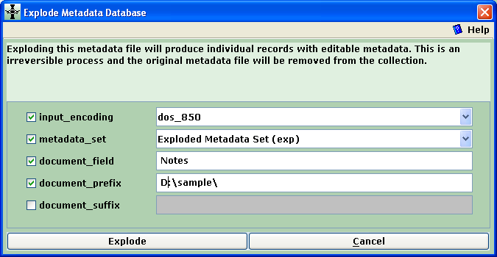
Figure 9: Specifying the Explode Metadata Database parameters

- input_encoding: If you are using non-ASCII characters in your CDS/ISIS database select the appropriate character set from the dropdown menu (for Latin alphabets it is "dos_850").
- metadata_set: This parameter (available only in version 2.70 and above) should be selected unless you want to ignore or combine some of the CDS/ISIS fields.
- document_field: Indicate the label (name) of the CDS/ISIS field containing the file name (in which case the document_prefix parameter is also required, as in this example) or the full path and filename of the electronic version of the document associated with the record (the document can be in any format accepted by Greenstone: htm, pdf, doc, ppt, etc.). Here we have specified the "Notes" field of the example CDS/ISIS application in which the document names have been added.
- document_prefix: Indicate the path (if any) to be prefixed to the contents of document_field.
- document_suffix: This parameter could contain the file extension if not included in the content of document_field.

The full document file path (concatenating document_prefix, document_field and document_suffix) may be either valid path on the local computer or network or a valid url on the Internet.

Leave the other options blank and click on Explode, then click on the OK button when informed that the explode process has been completed..

At this point the full-text document file corresponding to each record will have been copied into the "Greenstone\collection\xxx\import\YYY\" directory, where xxx is the name of the Greenstone database (in this case "cds") and YYY is the name of the CDS/ISIS database (in this case "CDS"). The metadata for the records has been written to a new "metadata.xml" file in the "Greenstone\collection\xxx\import\YYY" directory, and the metadata for each record is available for editing in the Enrich panel; the metadata elements will have the same names as the corresponding CDS/ISIS fields, preceded by the prefix "exp." (as opposed to ".ex" when an "as is" conversion is done).

Creation and replacement of dummy documents

If the user finds it inconvenient to place the paths and filenames of all or some of the associated electronic documents in the CDS/ISIS database, Greenstone can substitute the missing documents by dummy document files (files with zero length and ".nul" extension). In this case, the bibliographic metadata are attached to the dummy file. As and when the full documents become available, the "replace" function can be used to copy them into the collection to replace the corresponding dummy files.

The procedure is essentially the same as in Section A above. If the full document file path (concatenating document_prefix, document_field and document_suffix) is not valid, a dummy file will be created with filename derived from the concatenation and "nul" extension. If the concatenation is a null string (no data in document_prefix, document_field or document_suffix), dummy files will be sequentially created for the concerned records with filenames names 0001.nul, 0002.nul, etc. As before the metadata for each record is available for editing in the Enrich panel; the metadata elements will have the same names as the corresponding CDS/ISIS fields.

The library can now be configured, built and used just as if it contained actual documents (The NULPlug plugin must be loaded to process dummy documents, but this will normally not require action since NULPlug is loaded by default unless the collection is modeled on one without it.). When the document corresponding to a dummy file is available, one should right-click on the dummy file and then left-click on "Replace" as shown in Figure 10.

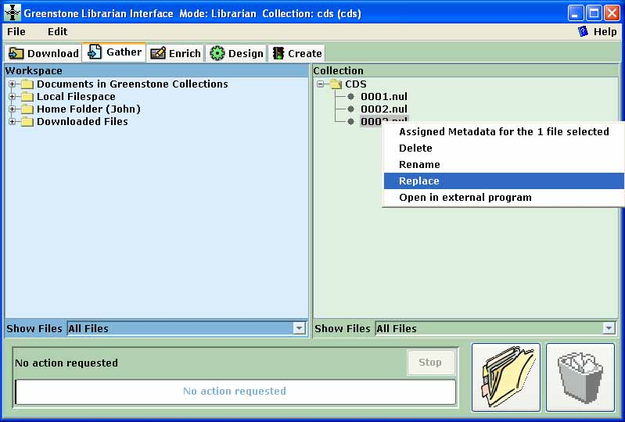
Figure 10: Menu presented after right click on a dummy file to be replaced

A browsing window (see Figure 11) will then enable the selection of the document file to replace the dummy file.

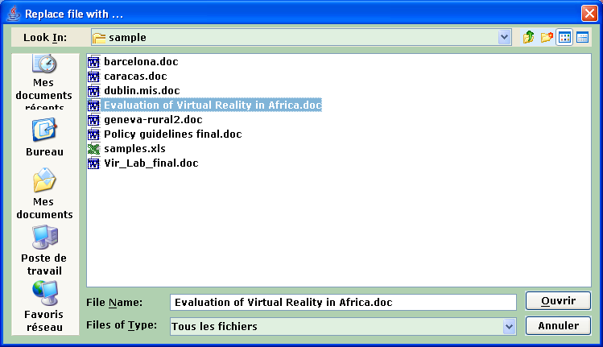
Figure 11: Choosing the document file to replace the dummy file

The collection can then be built, making sure in the Document Plugins view of the Design panel that the plugins needed to process the new documents (e.g. WordPlug and HTMLPlug for Word documents) have been loaded.

After the explode step as in either Section A or Section B above, you will be able to search and to browse the collection using the default interface. The collection can be finalized by configuring the search types, search indexes, browsing classifiers and format features in the Design panel (see Part 3).

It is possible to explode more than one CDS/ISIS databases into a single Greenstone collection, combining the documents of each and their metadata records. To do this, simply drag the files of an additional database (which can have different metadata structures) into the Collection pane and explode it. This technique can be used to update an existing collection with new documents (without having to rebuild the entire collection as is necessary when adding an additional database to an "as is" collection).

- CONFIGURING THE USER INTERFACE

This guide cannot go into all of the details of how to configure the end-user interface for your collection converted from CDS/ISIS. This part will provide only guidance for obtaining a basic acceptable configuration of search types, search indexes, browsing classifiers and format features, as well as a list of Greenstone documentation for more detailed or advanced configuration. The discussion that follows will refer to the default configuration parameters that are obtained by creating a new "as is" collection (see step 1.A.) or exploded collection. If you base your collection on an existing collection, the parameters will be those of the model collection (and thus in principle will be closer to those required for your collection and will require a lesser degree of modification).

Remember that, in Greenstone, search indexes and browsing classifiers (browsing lists) are different and must be specified separately. Any given metadata element may be indexed and/or be presented in a browsing classifier.

As shown in Figure 12, the search button is always at the upper left on the function bar of the collection homepage, and the browsing classifier buttons are to its right.

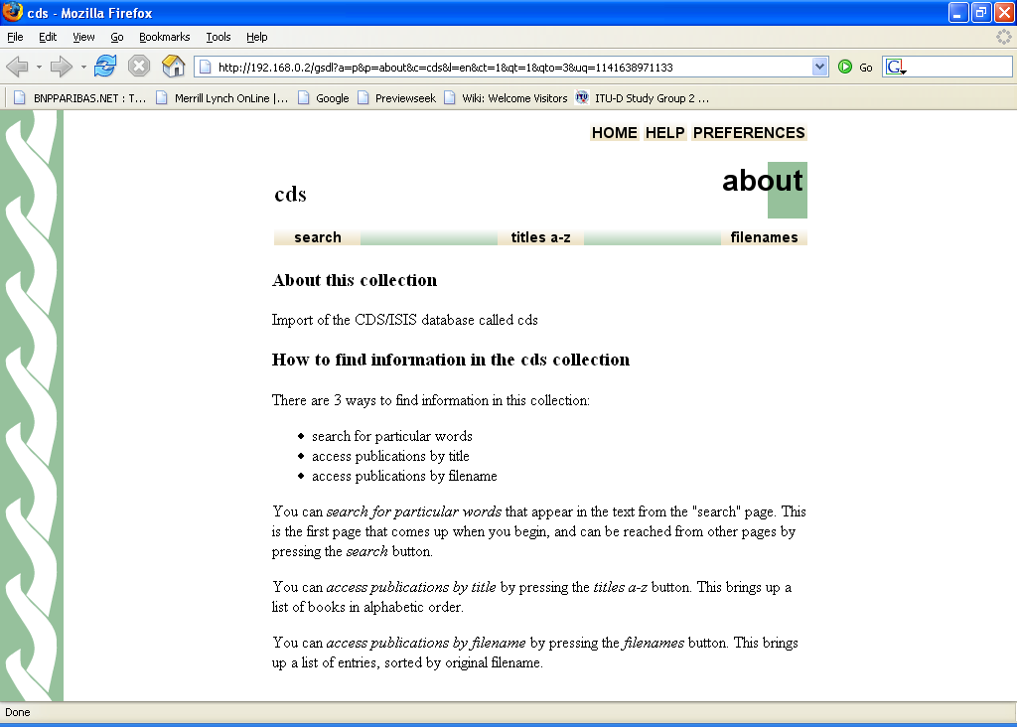
Figure 12: Homepage of the "cds" collection

Search Types (for versions 2.70 and earlier)

The default configuration is simple search (all search fields in the same index) and plain search type (a single box for search terms). In order to configure for advanced (multi-field) search with a the multi-field search form as default for the end user, go to the Search Types view of the Design panel and check the Enable Advanced Searches box. Then click on the Add Search Type button to add "form" search. Select "form" in the Currently Assigned Search types and click the Move Up button. You will then have the correct configuration shown in Figure 13.

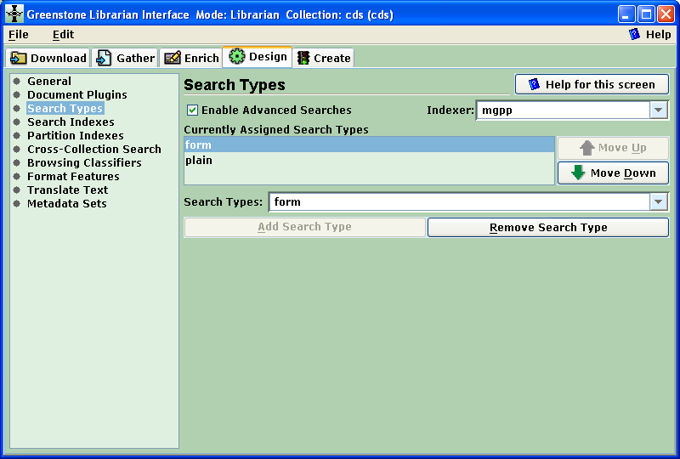
Figure 13: Parameters set for form search as default using multi-field searching

Available Metadata

To be able to follow the instructions in the following sections it is necessary to be able to recognize the metadata elements made available by Greenstone for the search indexes, browsing classifiers and display formats. For a given CDS/ISIS fieldname, the metadata extracted in an "as is" conversion have the prefix "ex" (e.g. ex.fieldname) and exploded metadata have the prefix "exp" (e.g. exp.fieldname).

In the case of a CDS/ISIS repeatable field, the following metadata elements are generated:
ex.fieldname (or exp.fieldname): The individual occurrences of fieldname
ex.fieldname^all (or exp.fieldname^all): Delimited list of all of the occurrences

In the case of a CDS/ISIS field with subfields, the following metadata elements are generated:
ex.fieldname^a (or exp.fieldname^a): Subfield "a"
ex.fieldname^* (or exp.fieldname^*): The first subfield (even if it is the main field
without a delimiting prefix) [from version 2.72]
ex.fieldname (or exp.fieldname): Delimited list of all of the subfields
ex.fieldname^all (or exp.fieldname^all): Same as above

In the case of a CDS/ISIS "pseudo-repeatable" field, the following metadata elements are generated:
ex.fieldname^sub (or exp.fieldname^sub): The individual delimited terms in fieldname
ex.fieldname (or exp.fieldname): The raw total content of fieldname
ex.fieldname^all (or exp.fieldname^all): Same as above

In an "as is" conversion the following metadata elements is generated for each record:
ex.ISISRawRecord The entire raw record
text A formatted version of the record intended for
standard display

Search Indexes

Go to the Search Indexes view of Design panel.

The Assigned Indexes by default will be (see Figure 14):
text "text" [index on the text of the record (in "as is" conversion) or of the linked document (in exploded conversion)]
ex.Title "Title" [index on the extracted title - this is only assured to be the real title if you have a CDS/ISIS field called Title and your collection has not be exploded]
ex.Source "Source" [index on the source file name (for an "as is" conversion it is YYY.MST for all records, where YYY is the name of the CDS/ISIS database, and thus useless)]

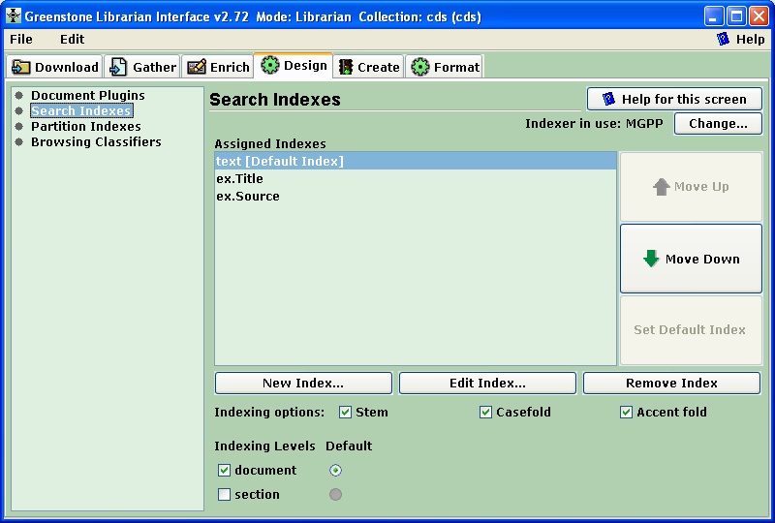
Figure 14: The view for setting search indexes (version 2.72)

For any index in the Assigned Indexes box , you can click on the Edit Index... button to change the metadata element(s) to be indexed; similarly, by clicking on the New Index... button, you can select the metadata element(s) to be indexed. To change the name of the index, open the Format panel and select the Search view from the menu.

For an "as is" conversion or if your library has been exploded to contain textual documents, you will normally keep the text index line to index the full record or the full associated document.

For an "as is" conversion, ex.Title should be kept for if there is a CDS/ISIS field called title; otherwise you should change to the element which does represent the title (e.g. "ex.Name"). For an exploded conversion, ex.Title will normally be useless and should be changed to "exp.Name" where Name is the CDS/ISIS field name containing the title of the document.

If you wish to search on file names in the case of an exploded database, then you may keep the ex.Source line.

For an exploded conversion, the list of metadata elements presented for selection as indexes includes the basic Greenstone extracted elements (ex.Title and ex.Source and the elements of the "exploded" metadata set (exp.zzz where zzz is the name of a CDS/ISIS field). In addition, if the metadata_set parameter has not been set (see Part 2, Section A) or for Greenstone versions prior to 2.70, you may also see other elements extracted by ISISPlug (ex.zzz where zzz is the name of a CDS/ISIS field). In that case do not specify the ex.zzz elements which are not operative; use the exp.zzz elements instead.

Browsing Classifiers

The classifiers are configured by selecting the Browsing Classifiers view in the Design panel which is shown in Figure 15.

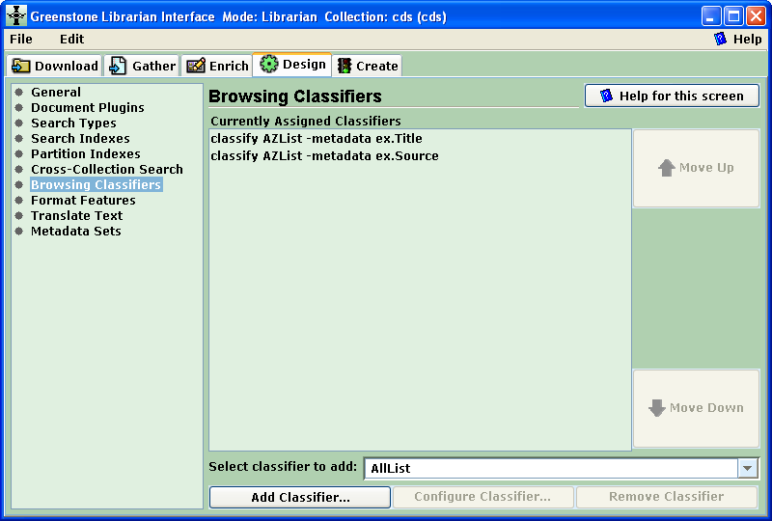
Figure 15: Browsing Classifiers view showing default classifiers

The classifiers proposed by default are:

classify AZList -metadata ex.Title [alphabetically sorted list ordered according to the extracted title - this is only assured to be the real title if you have a CDS/ISIS field called Title and your collection has not been exploded]
classify AZList -metadata ex.Source [alphabetically sorted list ordered according to the source file name (for an "as is" conversion it is YYY.MST for all records, where YYY is the name of the CDS/ISIS database, and thus useless)]

There are numerous classifier types available in Greenstone but for simplicity this guide will refer only the AZList (display of simple vertical list of records in alphabetical order) and AZCompactList (display of an alphabetically sorted vertical list of metadata values - clicking on one of the values yields a vertical list of the corresponding records in alphabetical order, similar to the list provided by AZList). The AZCompactList is used to browse metadata for which the same value can occur in several records, such as for authors and keywords.

For an exploded conversion, the list of metadata elements presented for selection as classifiers includes the basic Greenstone extracted elements (ex.Title, ex.Source, ex.Encoding and ex.Language) and the elements of the "exploded" metadata set (exp.zzz where zzz is the name of a CDS/ISIS field). In addition, if the metadata_set parameter has not been set (see Part 2, Section A) or for Greenstone versions prior to 2.70, you may also see other elements extracted by ISISPlug (ex.zzz where zzz is the name of a CDS/ISIS field). In that case do not specify the ex.zzz elements which are not operative; use the exp.zzz elements instead.

Classifiers are added, configured or removed using the Browsing Classifiers view (Figure 15). As a model, we will assume that the user wishes to enable browsing on title, authors and keywords, for which the following steps should be followed (in any order):
- Remove the source file browser by selecting the ex.Source line in the Currently Assigned Classifiers box and clicking on the Remove Classifier button.
- If the collection has been exploded or if the name of the title field of your CDS/ISIS database is other than "Title", then change the metadata element to be browsed in the title classifier line to the correct metadata name (e.g. if the title field in CDS/ISIS is "Name", then change the metadata element from. ex.Title to ex.Name for an "as is" conversion or to exp.Name for an exploded conversion). This is done by selecting the line specifying the desired element in the Currently Assigned Classifiers box and clicking on the Configure Classifier button to display the "Configuring Arguments" window (Figure 16):

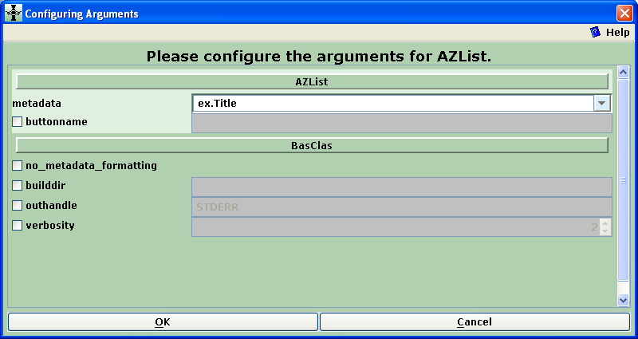
Figure 16: Configuration window for AZList classifier

Then you change the name of the metadata element to be browsed on in the top field and, if you want the browsing classifier to be given a name other than the metadata element name minus the prefix (in this case "Title"), check the buttonname box and type in the desired name. The click OK.
- Add the additional authors and keywords fields using the AZCompactList classifier type. For each classifier, Select AZCompactList in the Select classifier to add field of the Browsing Classifiers view (Figure 15), then click on the Add Classifier button to get the "Configuring Arguments" window (Figure 17). Select the name of the metadata element to be browsed on in the top field (if the field is repeatable or pseudo-repeatable, choose the occurrence metadata element rather than the entire field, e.g. ex.PersonalAuthors or "ex.Keywords^sub" rather than ex.PersonalAuthors^all or "ex.Keywords^all"). Set the mingroup parameter to "1" and, if you want the browsing classifier to be given a name other than the metadata element name minus the prefix (in this case "Personal Authors" instead of "PersonalAuthors"), check the buttonname box and type in the desired name. Then click OK.

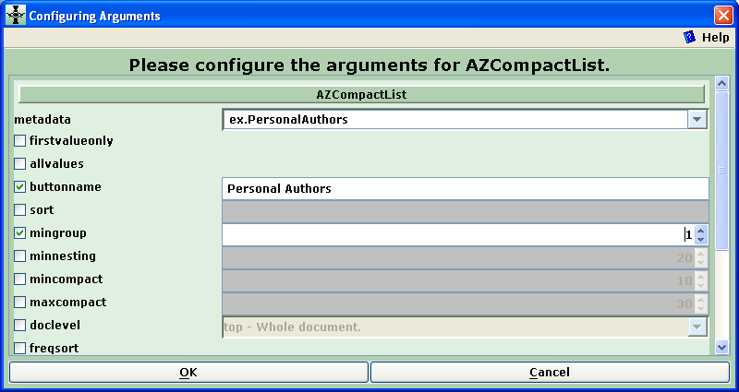
Figure 17: Configuration window for AZCompactList classifier

If the collection is rebuilt and previewed in the Create view, the new browser structure will appear in the homepage of the collection as seen in Figure 18. The order of the browser classifiers can be changed by selecting a line in the Currently Assigned Classifiers box, clicking on the Move Up or Move Down buttons as appropriate, and rebuilding the collection.

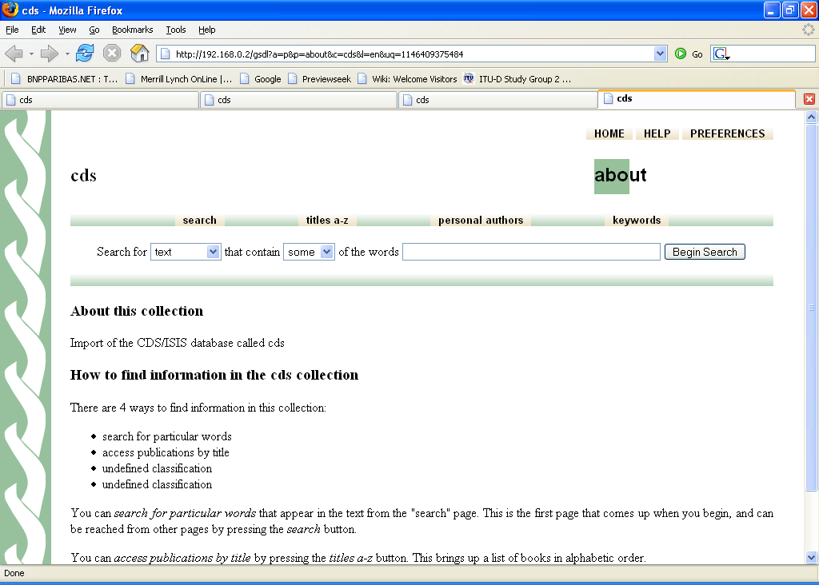
Figure 18: Modified browsing classifiers on the homepage of the "cds" collection

Format Features

Greenstone uses six principal display formats in Greenstone formatting language (modified html) to present metadata and documents to the end user. These display formats can be edited in the Format Features view of the Format panel (note that they can be changed and previewed in GLI without rebuilding the collection).

Four of the display formats (DateList, Hlist, VList, and DocumentButtons) determine the display of the record references in browsing lists and search results, while the two others (DocumentHeading and DocumentText) determine the display of the text of the full record (in "as is" conversion) or of the associated full-text document (in exploded conversion).

In most cases of conversions discussed in this guide, the user will find default display formats set by Greenstone to be acceptable. The two formats which users are most likely to wish to change are VList and DocumentText, which will be treated as examples below.

A third relevant formatting point covered below is the display of repeatable fields, fields with subfields, and "pseudo-repeatable" fields.

For more detailed formatting needs, the user is referred to the resources in Section F.

- VList is a format which determines how the record reference (including the title and other metadata determined by the user) is displayed vertically in the search results and browsing lists. It can be edited by selecting the line starting with "format VList" in the main Format Features box (DO NOT select it in the "Affected Component" field which is for adding new formats rather than modifying existing ones). The box with VList selected for editing is shown in Figure 19 (when working in Library Systems Specialist or Expert mode, MAKE SURE to expand the window to full screen to see the contents of the currently assigned format features).

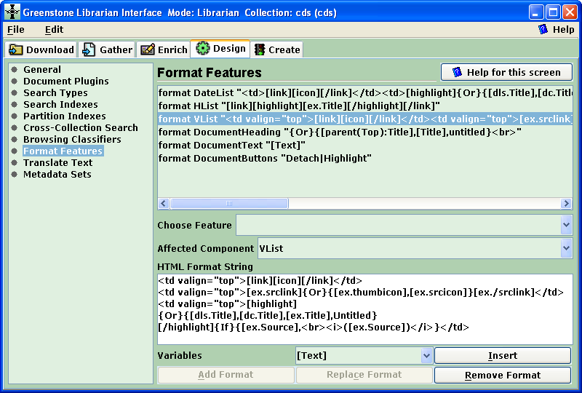
Figure 19: Format Features window ready for the editing of VList

VList can now be edited in the HTML Format String box by simply typing in the box and/or inserting specified metadata elements or standard format elements by choosing them in the drop-down list of Variables and clicking on the Insert button. When the editing is complete, click on the Replace Format button.

The default version of VList is:

<td valign=top>[link][icon][/link]</td>
<td valign=top>[ex.srclink]{Or}{[ex.thumbicon],[ex.srcicon]}[ex./srclink]</td>
<td valign=top>[highlight]
{Or}{[dls.Title],[dc.Title],[ex.Title],Untitled}
[/highlight]{If}{[ex.Source],<br><i>([ex.Source])</i>}</td>

For example, if one wants the list of authors in parentheses instead of the source file name in parentheses, the last line may be changed to:

[/highlight]{If}{[ex.PersonalAuthors^all],<br><i>([ex.PersonalAuthors^all])</i>}</td>

The only major problem with the default VList format would be if the CDS/ISIS title field is called something other than "Title". For example if this field is called "Name", the fourth line of the Vlist format should be changed to the following:

{Or}{[ex.Name],Untitled} [This displays the value of ex.Name if this field exists, else the mention "Untitled".]

To get back the default setting of the format, remove the format, then reopen the collection clicking on the File/Open... main menu item

- The DocumentText format displays the full text associated with a selected record (the full CDS/ISIS record in the case of "as is" conversion, or the full electronic document if it has been imported through the explode method). If an electronic document has been imported, then the default value of this format will normally suffice.

However, if the display text is intended to be the CDS/ISIS record (not the associated document), the user may wish to modify the display. In an "as is" conversion this is less likely since the default is a specifically designed text metadata element generated by ISISPlug from the raw CDS/ISIS record (named ex.ISISRawRecord and searchable as raw record). However, in the case of an exploded conversion in which there are dummy documents (for which the text metadata will be null), the DocumentText format should be edited (in the same way as was done for VList above) to show the metadata elements in the desired way.

For example, for an exploded conversion, if the default format ([Text]) is changed as follows:

Title: [exp.Title]<br>Authors: [exp.PersonalAuthors^all]<br>Publisher: [exp.Imprint^all]<br>Keywords: [exp.Keywords^all]<br>[Text]

the text of one specific record would display as:

Title: Policy Guidelines for the Development and Promotion of Governmental Public Domain Information
Authors: Uhlir, P.F.
Publisher: Paris, UNESCO, 2004
Keywords: public domain, digital information, open access, copyright

followed by the full text of the associated document if it is in the collection.

- The ISISPlug plugin has two formatting parameters which affect the display of repeatable field and subfield metadata. These are the entry_separator and subfield_separator paramaters which can be edited by checking the corresponding boxes in the "Configuring Arguments" window for ISISPlug (Figure 20) which is obtained by selecting ISISPlug in the Document Plugins view of the Design panel, and then clicking on the Configure Plugin button (see Figure 3). These parameters are useful in changing the content of metadata element for full field in the case of repeatable fields and fields with subfields.

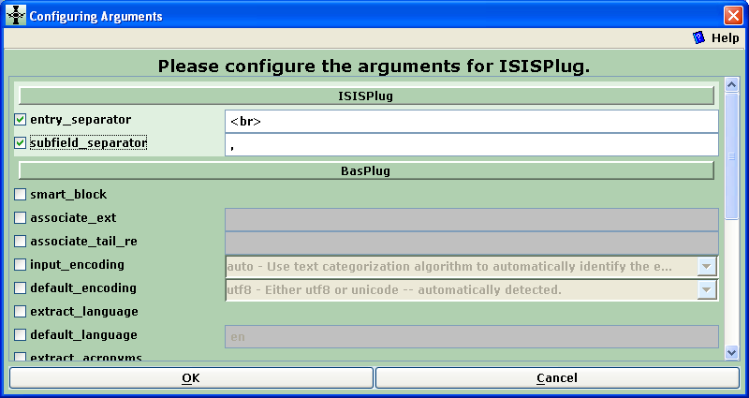
Figure 20: Formatting parameters selected in ISISPlug

The entry_separator parameter controls how the combined content of a repeatable field (designated in Greenstone as ex.fieldname^all) is derived from the individual occurrences; the default is <br> which generates a combined field with the a new line between occurrences.

The subfield_separator controls how combined content of a field with subfields (the identical metadata elements designated as ex.fieldname and ex.fieldname^all) is derived from the individual subfields; the default value is a comma followed by a space (the space is entered in the parameter but not explicitly displayed in the input line), which generates a combined field consisting of the subfields separated by comma-space.

For "pseudo-repeatable" fields there is no metadata element for delimited occurrences (ex.fieldname and ex.fieldname^all contain the raw field with delimiters). One can generate a string of the occurrences with a chosen separator (e.g. " - ") by using the following format:

[sibling(All' - '):ex.fieldname^sub]

Resources for detailed guidance

The following resources may be consulted for more complete/advanced guidance on configuring Greenstone search types, search indexes, browsing classifiers and format features.

  - A summary of all formatting features and commands:
http://greenstone.sourceforge.net/wiki/index.php/How_to_format_the_output_of_your_collection

  - Some example collections which have documentation about their configuration:
http://greenstone.sourceforge.net/wiki/index.php/Example_collections

  - Section 2.3 of the Greenstone Developer's Guide:
http://prdownloads.sourceforge.net/greenstone/Develop-en.pdf

  - Fiji workshop, greenstone tutorials, downloadable from:
http://greenstone.sourceforge.net/wiki/index.php/Tutorial_exercises

- CONVERTING VERY LARGE CDS/ISIS DATABASES

Users with very large CDS/ISIS databases may experience difficulties in attempting to convert them to Greenstone collections using GLI. In such cases GLI may hang up or work for an inordinate amount of time without a result. This section is intended to advise on steps which may be taken to overcome such problems.

Explode function

GLI may fail at the explode step because it wasn't designed to handle huge amounts of metadata (generally those approaching 15,000 records, but possibly less or greater depending on the size of the CDS/ISIS records).

If the problem is due to slowness rather than metadata overload, it may be able to be solved by adjusting the records_per_folder parameter in the Explode Metadata Database window (available only starting from Greenstone version 2.72). This puts the records from exploding a metadata database into multiple subdirectories, which means that the GLI should use less memory and edit the metadata more quickly. The default value is 100, so you can try a lower value, say 10.

If the explode function of GLI fails, there are three choices:

i) You may break the CDS/ISIS database into several sub-databases (exporting different MFN ranges to separate ISO files in CDS/ISIS, and reimporting them to CDS/ISIS databases with different names). You can then build separate Greenstone collections to be searched with the cross-collection search facility (to be set in the GLI Format panel). This has the disadvantage that browsing across more than one the sub-databases at one time will not be possible.

ii) You can convert your CDS/ISIS database "as is" rather than exploding it; see section 1 of the Creating Digital Libraries Based on CDS/ISIS Databases (http://greenstone.sourceforge.net/wiki/gsdoc/others/CDS-ISIS_to_DL.doc) to set up the "as is" collection and the section 2 of the present guide if there is trouble with building the "as is" collection.

iii) You can switch to Greenstone command line mode, explained in detail in section 3. Note that if the command line is necessary to perform the explode step, it will also be required to build the collection (GLI cannot be expected to create a collection with more metadata than it could handle at the explode step).

Create panel

GLI may also hang up or work for an inordinate amount of time without a result in the Build Collection process within the Create panel. This may happen in an "as is" conversion or when building a collection set-up using the explode function.

The first thing remedy to try is changing the groupsize parameter. For this, set GLI to Library Systems Specialist or Expert mode in the File/Preferences menu item, and set groupsize, which is 1 by default, to a larger number such as 100 or 1000 before rebuilding. groupsize controls how many documents go into one doc.xml file in the archives directory. Increasing groupsize is unlikely to allow a build to complete correctly if it does not work with a smaller groupsize, but should decrease the time required for a successful build.

Command mode

If the explode or build function cannot be performed in GLI, you should build your collection from the command line as explained in Chapter 1 of the Greenstone Developer's Guide (http://prdownloads.sourceforge.net/greenstone/Develop-en.pdf). The first step is to save and close your collection in GLI.

Under Windows, the next step is to get at the "command prompt", the place where you type commands. Try looking in the Start menu, or under the Programs submenu, for an entry like MS-DOS Prompt, DOS Prompt, or Command Prompt. If you can't find it, invoke the Run entry and try typing "command" (or "cmd") in the dialog box. If all else fails, seek help from one who knows, such as your system administrator.

Change into the directory where Greenstone has been installed. Assuming Greenstone was installed in its default location, you can move there by typing
cd "C:\Program Files\Greenstone"
(You need the quotation marks because of the space in Program Files.) Next, at the prompt type
setup.bat
This batch file (which you can read if you like) tells the system where to look for Greenstone programs.1 If, later on in your interactive session at the DOS prompt, you wish to return to the top level Greenstone directory you can accomplish this by typing cd "%GSDLHOME%" (again, the quotation marks are here because of spaces in the filename). If you close your DOS window and start another one, you will need to invoke setup.bat again.

Now you are in a position to make, build and rebuild collections. The Greenstone Developer's Guide speaks first about the Perl program "mkcol.pl", whose name stands for "make a collection". You don't have to do this since you have already created the collection. Since you have already dragged the CDS/ISIS database files into collection through the GLI Gather panel, you don't have to copy the document files for the collection into the import directory, either. Similarly, you don't have to do worry either about editing the "collect.cfg" file since all of the information about metadata sets, indexes, browsing classifiers and formats will already have been saved in this file by GLI.

If GLI failed at the explode step, then this step can be implemented from the command line by typing
perl -S explode_metadata_database.pl -plugin ISISPlug -metadata_set exp <path to CDS/ISIS MST file>

Now type
perl –S import.pl -removeold your_collection_name
at the command prompt. "your_collection_name" is the short collection name of your collection (the first data that you entered into GLI for this collection). Don't worry about all the text that scrolls past—it's just reporting the progress of the import. Note that you do not have to be in either the collect or your_collection_name directories when this command is entered; because GSDLHOME is already set, the Greenstone software can work out where the necessary files are.

Next type
perl –S buildcol.pl your_collection_name
at the command prompt Don't worry about the "progress report" text that scrolls past.

Make the collection "live" as follows: select the contents of the collection's building directory (in principle, greenstone\collect\your_collection_name\building) and drag them into the index directory (in principle, greenstone\collect\your_collection_name\index). Alternatively, you can remove the index directory (and all its contents) by typing the command
rd /s index (under Windows NT/2000/XP) or
deltree /Y index (under Windows 98)
and then change the name of the building directory to index with
ren building index
Finally, type
mkdir building
in preparation for any future rebuilds. It is important that these commands are issued from the correct directory (unlike the Greenstone commands mkcol.pl, import.pl and buildcol.pl). If the current working directory is not "your_collection_name", type
cd "%GSDLHOME%\collect\your_collection_name"
before going through the rd, ren and mkdir sequence above.

You should now be able to access the newly built collection from your Greenstone homepage. You will have to reload the page if you already had it open in your browser, or perhaps even close the browser and restart it (to prevent caching problems). Alternatively, if you are using the "local library" version of Greenstone you will have to restart the library program. To view the new collection, click on the image or collection name that you had originally set in GLI.

http://www.unesco.org/webworld/isis
Relative to version 2.70, version 2.72 supports the ^* metadata element, does not import logically deleted records (with prior versions, one had to export to an ISO file and re-import into CDS/ISIS before converting to Greenstone), and includes several less important fixes and features. If problems are encountered with version 2.70, the first reflex of the user should be to try to upgrade to version 2.72 or later.
The ISISPlug plugin enabling search and display of CDS/ISIS metadata in Greenstone has been available since version 2.50, and the explode function, enabling the creation of CDS/ISIS databases which can be updated in Greenstone and the integration of the full-text documents corresponding to bibliographic records, has been available since version 2.60. The following major improvements are available only in versions 2.70 and above: * Correct handling of "pseudo-repeatable" CDS/ISIS fields (non-repeatable fields with occurrences delimited by "<" and ">" (Indexing technique 2) or by "/" and "/" (Indexing technique 3). Prior to version 2.70 only Indexing technique 2 is handled, but only for a CDS/ISIS field named "Keywords". * Generation of a proper record display by ISISPlug. Prior to version 2.70 extensive reformatting was necessary for "as is" conversions of bibliographic databases (as in the Greenstone CDS/ISIS example application) unless the bibliographic records are in the CDS format of UNESCO. * The "replace" function enabling full-text documents associated with bibliographic records to be easily integrated into the Greenstone library of bibliographic records. Prior to version 2.70, if the documents were are imported at the time of digital library creation from a CDS/ISIS field, each new document must be manually specified in the metadata.xml file.
Other FOSS/freeware options available for presentation of native CDS/ISIS databases "as is" on the Web include: 1. GenISIS is freeware available from UNESCO (http://www.unesco.org/webworld/isis) to create a customized server-end application for querying CDS/ISIS databases. It requires the WWWISIS software of the Latin American and Caribbean Center on Health Sciences Information (BIREME); version 3.0 of WWWISIS (distributed by UNESCO) is sufficient for serving under Windows, whereas a later version (also called WXIS) is required to run under Linux/Unix (since December 2006 all versions of WWWISIS have been available free of charge from BIREME). 2. The JavaISIS package of UNESCO requires installation of the JavaISIS Server at the server end and the JavaISIS Client at the user end. Users can retrieve, create, modify and display records, and import and export records using the ISO2709 format. Multilingual encoding support is provided. Since JavaISIS also requires WWWISIS, it works only under a Windows based Web server unless version 4.0 or later of WWWISIS is acquired. 3. CLABEL can be used to serve a CDS/ISIS database over Linux/Unix. It requires OpenISIS and PHP-OpenISIS (all three are FOSS programs available at http://www.sourceforge.org). 4. Igloo (http://igloo.lib.itb.ac.id/) can be used either over OpenISIS and PHP-OpenISIS or over PHP-OpenIsis for Windows.
See, for example, Chapter 3 of the Greenstone User's Guide (http://prdownloads.sourceforge.net/greenstone/User-en.pdf) or the FAO IMARK training module on Digitization and Digital Libraries (http://www.imarkgroup.org/), followed as required by the more advanced sources in section 3 of this guide.
In version 2.70, after requesting a new collection, you are proposed a list of metadata sets; uncheck Dublin Core Metadata Element Set and click OK and then OK again in the warning box (you do not need a metadata set for this step, metadata will be generated from the CDS/ISIS file structure).
For versions prior to 2.70, their may be a warning when dragging the XRF and FDT files to the effect that "None of Greenstone's plugins are expected to process the file" - simply click on OK.
Integration of the documents is required to index their full text within Greenstone, and may be useful to package the whole library and to compress the files; however, in an "as is" conversion, files identified in the bibliographic records by valid url's will be accessible from the Greenstone library.
Note that it is only after the collection is built the first time that the CDS/ISIS metadata are extracted and available to create indexes, browsing classifiers and display formats.
If your CDS/ISIS collection has several thousand records, it could be useful to switch to "Library Systems Specialist" mode, and to set the groupsize parameter to say, 200 before clicking on Build Collection. Bibliographic collections typically have many small documents, and grouping them together prevents Greenstone's internal file structures from becoming bloated and occupying more disk space than necessary.
This classifier will work correctly by default only if the CDS/ISIS database has a field entitled "Title".
The filename for all of the records is the MST file, so this classifier is not useful.
In collections built with Greenstone versions prior to 2.70 (including the isis-e example collection), by default the records will appear in raw format in which tag names and field data are strung together without line breaks between them; the improved standard presentation can be obtained by rebuilding these collections in version 2.70.
If you are using a version of Greenstone prior to 2.70, you will also probably want to modify the display format features (see Part 3, Section E).
The example collections can be downloaded from http://prdownloads.sourceforge.net/greenstone/gsdl-documented-collections-aug2005.zip (if your CDS/ISIS example collection came with a version of Greenstone prior to 2.62, for example the UNESCO CD-ROMs published in 2004 (Greenstone version 2.50) or 2005 (Greenstone version 2.60), it will only work properly in version 2.62 and above if you download and install the updated version of the Greenstone\collect\isis-e\etc\collect.cfg file at http://www.cs.waikato.ac.nz/~mdewsnip/greenstone/collect.cfg).
The explode option also works with other plugins designed to handle metadata databases, like BibTexPlug or MARCPlug.
The explode function erases the copies of the CDS/ISIS files which was dragged into GLI, but not the originals in your CDS/ISIS database (in versions prior to 2.70 only the MST file is erased).
If the metadata_set parameter has not been set in versions 2.70 and above, or if you are using version 2.6x, you will first be prompted to add, merge or ignore each of the CDS/ISIS fields through a dialogue box. For each metadata element, click on the Add button to assign data to it, the Merge button to combine this data with a Target metadata element, or the Ignore button to ignore the element. Then click on the OK button when informed that the explode process has been completed.
Prior to version 2.70 the exploded metadata was not automatically fixed into an editable metadata set. In versions 2.6x use the following method to be able to edit the metadata: Open the separate Greenstone Editor for Metadata Sets (GEMS) program and open a new metadata set (File/New... main menu item). Give it a full Name and a unique short name (Namespace) and click OK. Then select the metadata set in the left panel and click on the Save item in the File menu. A blank metadata set will be saved in a file named Namespace.mds (in this case, cds.mds). Now go back to your Greenstone collection in GLI and add the newly created blank metadata set in the Metadata Sets view of the Design panel. Add all of the extracted metadata set items one by one as prompted to the new dataset. The metadata with elements named Namespace.fieldname will now be editable in the Enrich panel.
For example, because the user wishes to set up a bibliographic database in Greenstone with the intention of gradually incorporating the associated documents, or simply because it is inconvenient the automate the transfer due to documents scattered among different storage units and directories.
In Greenstone versions 2.6x, there is an additional parameter called filename_field in the Explode Metadata Database window which is used to generate the dummy file names.
This function is only available starting in version 2.70. In versions 2.6x it is necessary to delete the dummy file in the Collection pane of the Gather panel and drag in the document file. Then, before building, the user must use a text editor like WordPad to change the line "<FileName>filename\.nul</FileName>" in the metadata.xml file (in the Program Files\Greenstone\collect\xxx\import\YYY directory) by replacing "filename\.nul" by the full file name (name and extension, e.g. "actualfilename\.doc") of the actual electronic document.
In version 2.72, this menu item is not available; the search type can be changed at the time of use of the collection in the preferences of the Greenstone interface.
In version 2.70, there is no Format panel, and you can change the "Index Name" (presented in quotes in the corresponding line in the Assigned Indexes box) and/or "Build index on" (the metadata element to be indexed) by selecting the target line in the Assigned Indexes box in the Search Indexes view of the Design panel, and then by changing the data in the two corresponding spaces below it (NOTE that the Add Index and/or Replace Index buttons only become active when you have made a change in "Index Name" or "Build index on" parameters).
In Greenstone versions prior to 2.63, specifying the buttonname parameter may cause the changed classifier names to appear as underlined text rather than as buttons, because there is no button in Greenstone corresponding to the names of the classifiers (here PersonalAuthors and Keywords). Buttons are available for all of the metadata elements of the metadata sets provided with Greenstone (one can see the elements of any metadata set by temporarily adding it in the Metadata Sets view of the Design panel, and then removing it after review, or by using the Greenstone Editor for Metadata Sets (GEMS)). For example, you will see that "Keyword" rather than "Keywords" exists in the Development Library Subset (dls) metadata set, and knowing this, you can set the buttonname parameter in the classifier configuration window to "Keyword" and rebuild to get this button on the collection homepage. If you want to insert a button with an unsupported name, there is a page on the Greenstone website that can be used to generate a new button in the default Greenstone style (http://www.cs.waikato.ac.nz/~mdewsnip/greenstone/make-images.html).
In version 2.70, there is no Format panel, and the Format Features view is found in the Design panel.
However, in Greenstone versions prior to 2.70, text contains the raw record which the user is likely to want to modify.
When a parameter's box is not checked, the values shown in gray characters on gray background are active but cannot be edited.
In version 2.63 and before, this has to be written as "&lt;br&gt;" using the sequences to represent the" less than" (<) and "greater than" (>) brackets in HTML.
In this case, it is likely that the metadata.xml files are too large for GLI to handle. It would be appreciated if you set GLI to Expert mode in the File/Preferences menu item, rerun the explode process, and report the error message (for example, 'out of memory can not parse metadata.xml') and details on the total size of the database and the number and size of the CDS/ISIS records to one of the Greenstone discussion lists.

